CH Grocers

Trader Dashboard Guide

This trader dashboard guide will control you through the features of the trader dashboard and will likewise enable you to explore through the trader dashboard effortlessly. Likewise, to ensure you don't have the problem of perusing long, exhausting and pointless aides, we've attempted our best to make this short, straightforward and justifiable. In the event that you have any further inquiries that the guide couldn't deliver please don't hesitate to get in touch with us on [chgrocers123@gmail.com](mailto:chgrocers123@gmail.com)

# Trader Interface Login

You can log in as a trader if you are registered as a trader on the website. You can see a trader login option where you can enter the right credentials to login.

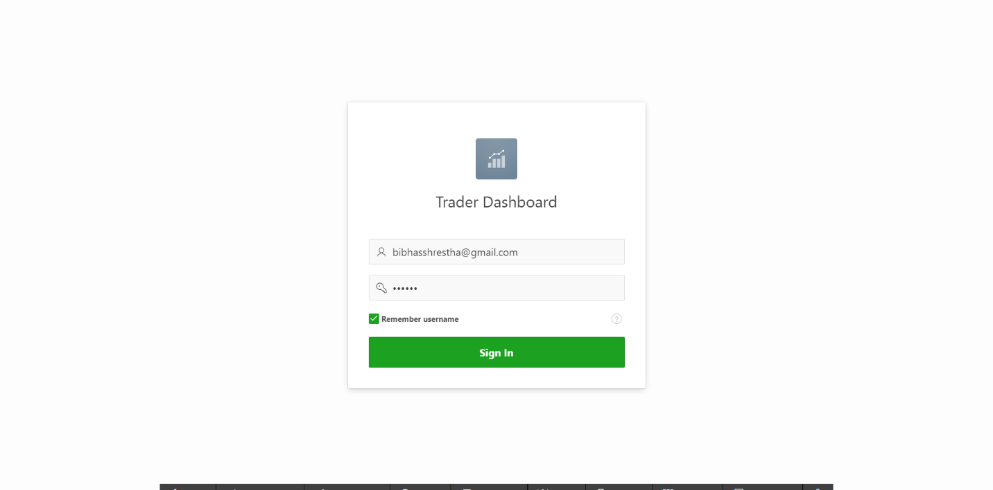

# Trader Dashboard

You can view the report on the price of the products.

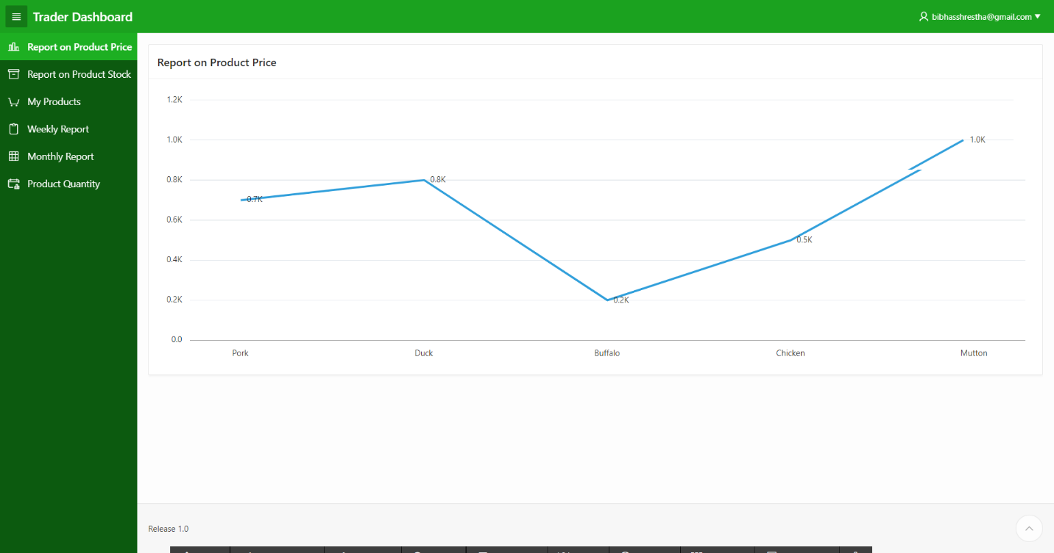

# Product Management

The trader can view the interactive report on my products page where the trader can check the product date, product price, product quantity.

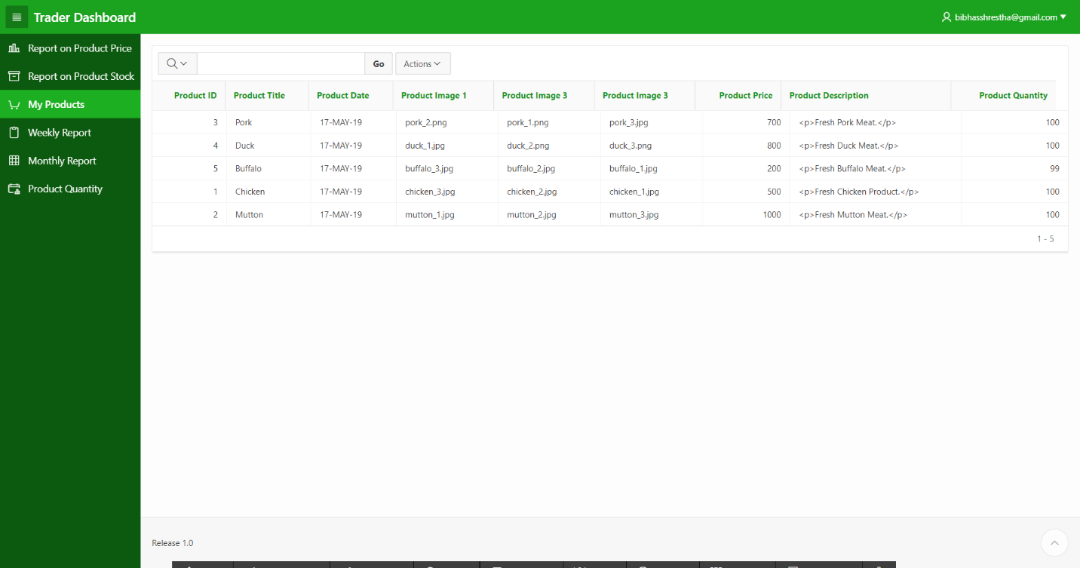

# Report on Product Stock

The trader can view the stock of his product which is graphically represented through a pie-chart.

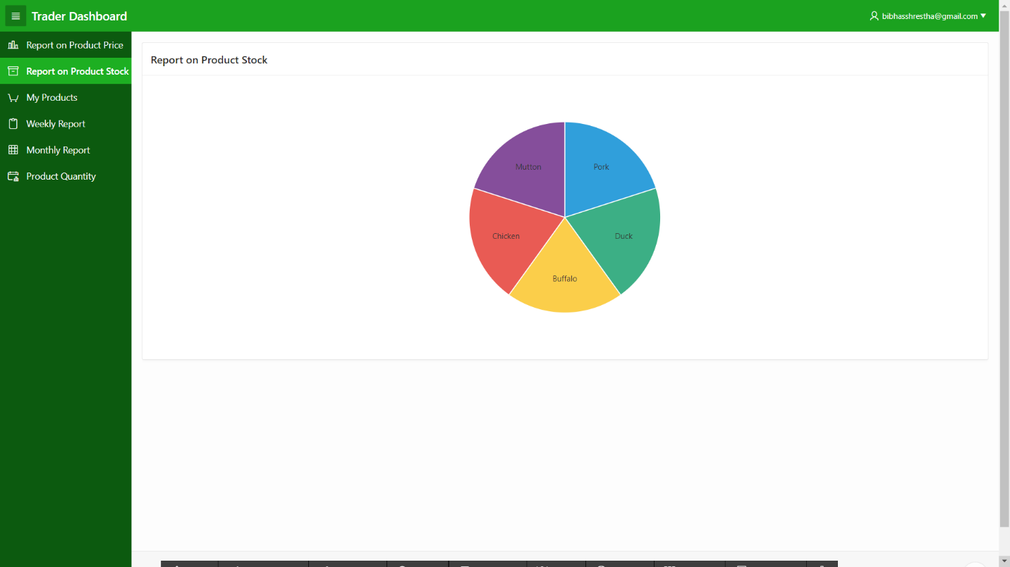

# Report on Product Quantity

The trader can view the quantity of his product which is graphically represented through a bar graph.

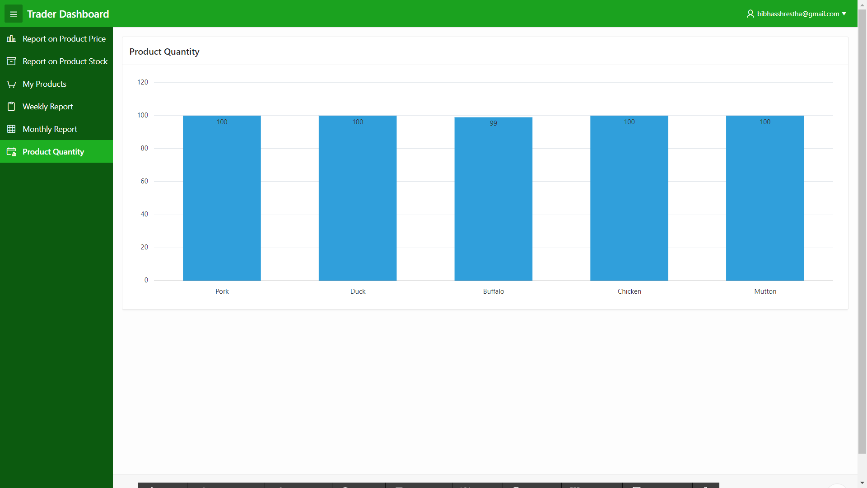r

# Weekly Report

The trader can view the weekly report after clicking on the link where the trader can view the order amount, order invoice and the product sales.

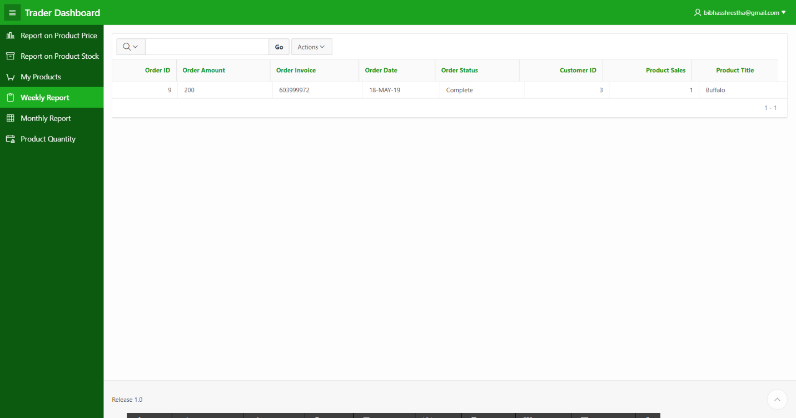

# Monthly Report

The trader can view the monthly report after clicking on the link where the trader can view the order amount, order invoice and the product sales.

